**Probability and Statistics**

**Assignment 5**

**Total Mark:100 sections: AI (J), AI (K), DS (N), cyber security (M)**

**Open date:17 -5- 2021**

**Submission Date: 22 -5- 2021**

**On line submissions for sections AI (J), AI (K):**  i180721@nu.edu.pk

**On line submissions for sections DS (N), cyber security (M):**  <i180646@nu.edu.pk>

**Question No.1:**

An overseas shipment of 5 foreign automobiles contains 2 that have slight paint blemishes. If an

agency receives 3 of these automobiles at random, list the elements of the sample space S, using the letters B and N for blemished and non-blemished, respectively; then to each sample point assign a value x of the random variable X representing the number of automobiles with paint blemishes purchased by the agency.

**Question No.2:**

An investment firm offers its customers municipal bonds that mature after varying numbers of years. Given that the cumulative distribution function of T, the number of years to maturity for a randomly selected bond, is

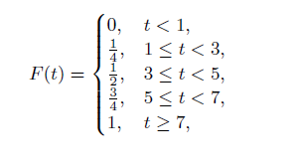

find

(a) P (T = 5);

(b) P (T > 3);

(c) P (1.4 < T < 6);

**Question No.3:**

The discrete random variable ‘W’ has probability distribution as shown

|  |  |
| --- | --- |
| **W** | **P(W=w)** |
| -3 | 0.1 |
| -2 | 0.25 |
| -1 | 0.3 |
| 0 | 0.15 |
| 1 | d |

Find,

(a) Value of d

(b) P (-3 <= W < 0)

(c) P (W > -1)

(d) P (-1 < W < 1)

**Question No.4:**

The total number of hours, measured in units of 100 hours, that a family runs a vacuum cleaner over a period of one year is a continuous random variable X that has the density function

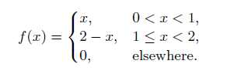

Find the probability that over a period of one year, a family runs their vacuum cleaner

(a) less than 120 hours;

(b) between 50 and 100 hours.

**Question No.5:**

Suppose a certain type of small data processing firm is so specialized that some have difficulty making a profit in their first year of operation. The probability density function that characterizes the proportion Y that makes a profit is given by

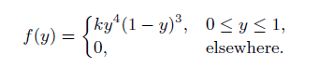

(a) What is the value of k that renders the above a valid density function?

(b) Find the probability that at most 50% of the firms make a profit in the first year.

(c) Find the probability that at least 80% of the firms make a profit in the first year.

**Question No.6:**

Measurements of scientific systems are always subject to variation, some more than others. There are many structures for measurement error, and statisticians spend a great deal of time modeling these errors. Suppose the measurement error *X* of a certain physical quantity is decided by the density function



(a) Determine *k* that renders *f*(*x*) a valid density function.

(b) Find the probability that a random error in measurement is less than 1/2.

(c) For this particular measurement, it is undesirable if the *magnitude* of the error (i.e., *|x|*) exceeds 0.8. What is the probability that this occurs?

**Question No.7:**

(a)

Let X denote the amount of space occupied by an article placed in a 1-ft3 packing container. The pdf of X is

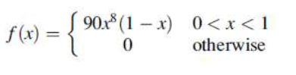

(i) Graph the pdf. Then obtain the cdf of X and graph it.

(ii) What is P (X <= 0.5)?

(iii) Using part (a), What is P (0.25 < X <= 0.5)? What is P (0.25 <= X <= 0.5)?

(b)

The random variable X has cumulative distributive function

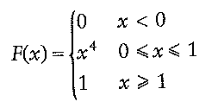

Find

(i) P (0.3 < X < 0.6),

(ii) the value of a such that P (X > a) = 0.4